**Create a Design Specification**

**1. Brief descriptions of one key process that will be implemented in your application.**

A key process in the **Condominium Plus System** is the Broadcast Announcements. To carry out this process, the Condos Manager will first login on platform and in Bulletin section creates a new announcement.

The Condo Resident and Condo Unit Owner after login the platform will review if the profile has been completed, if not the system will show up the profile screen to complete.

If the profile is complete or after could view the announcements related to Events, Schedule Maintenance, New Residents, etc. on main Dashboard.

The user could type a comments about the announcements received and collaborates with the other Resident together in real time.

**2. An image showing the steps a user goes through in this key process.**

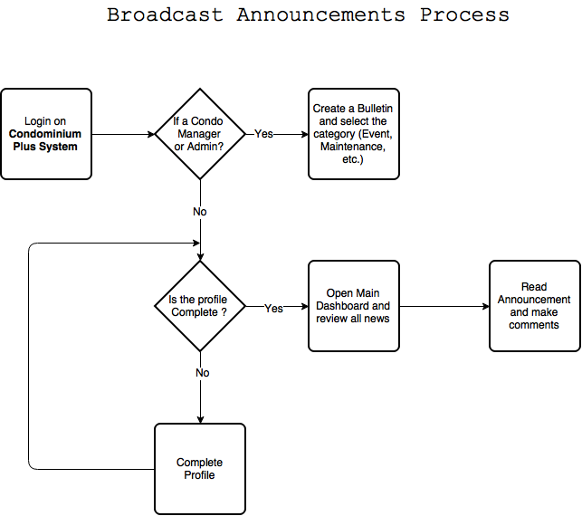

**3. Wireframe mock ups of the layout for one key page in your application.**

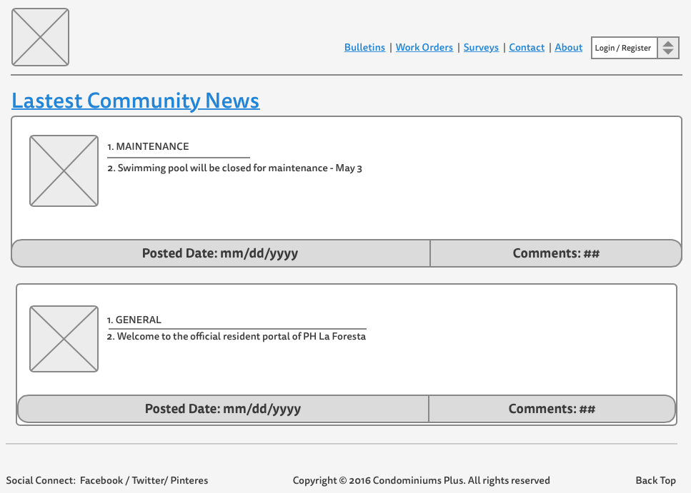

Todo

1. SWOT

2. Prepare Design Specifications

1. Investigate about option for build a prototype

2. Start a develop my prototype

May 19, 2016

**What were the tasks you set yourself last time?**

1. Investigate about option for build a prototype (complete)

2. Start a develop my prototype (complete a sent with delay)

**Reflect on the tasks you set yourself. What went well, what went badly?**

1. Web Development now is on time

2. Final presentation is in progress

3. Use GitHub for backup with regular

**Write a list of things you plan to do next time.**

1. Complete Final presentation.

2. Complete some look and feel of my project